TASK -2
PROFILE

LINKEDIN
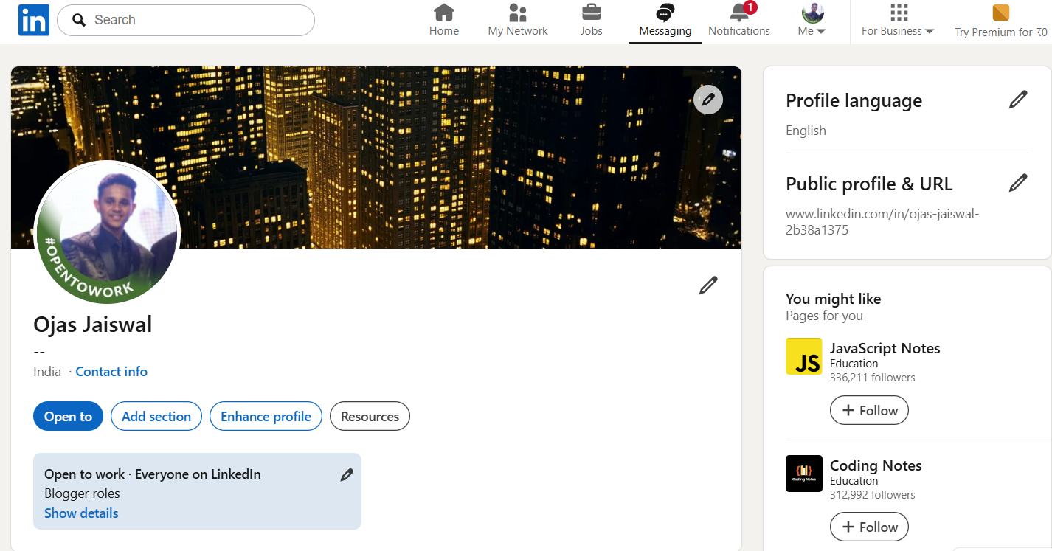
VISIT LINKEDIN

GITHUB
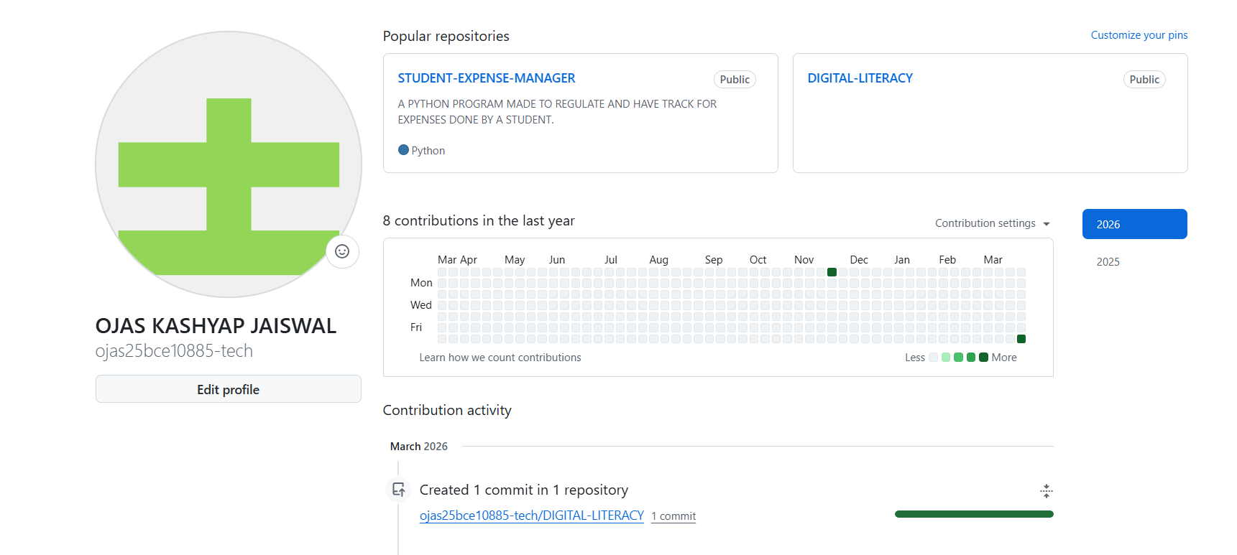
VISIT GITHUB

KAGGLE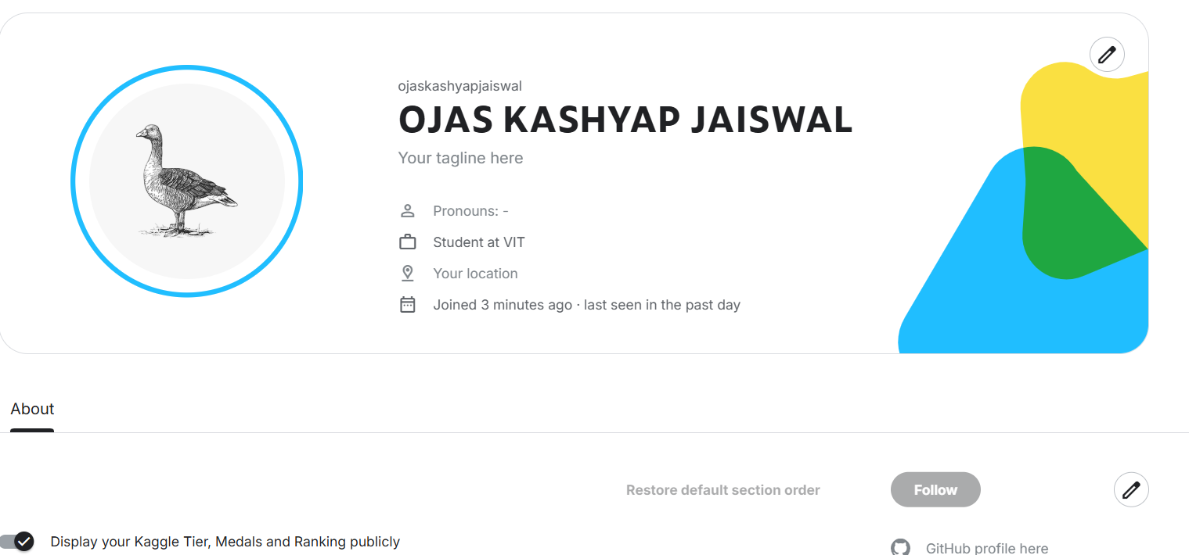
VISIT KAGGLE

Hackerank
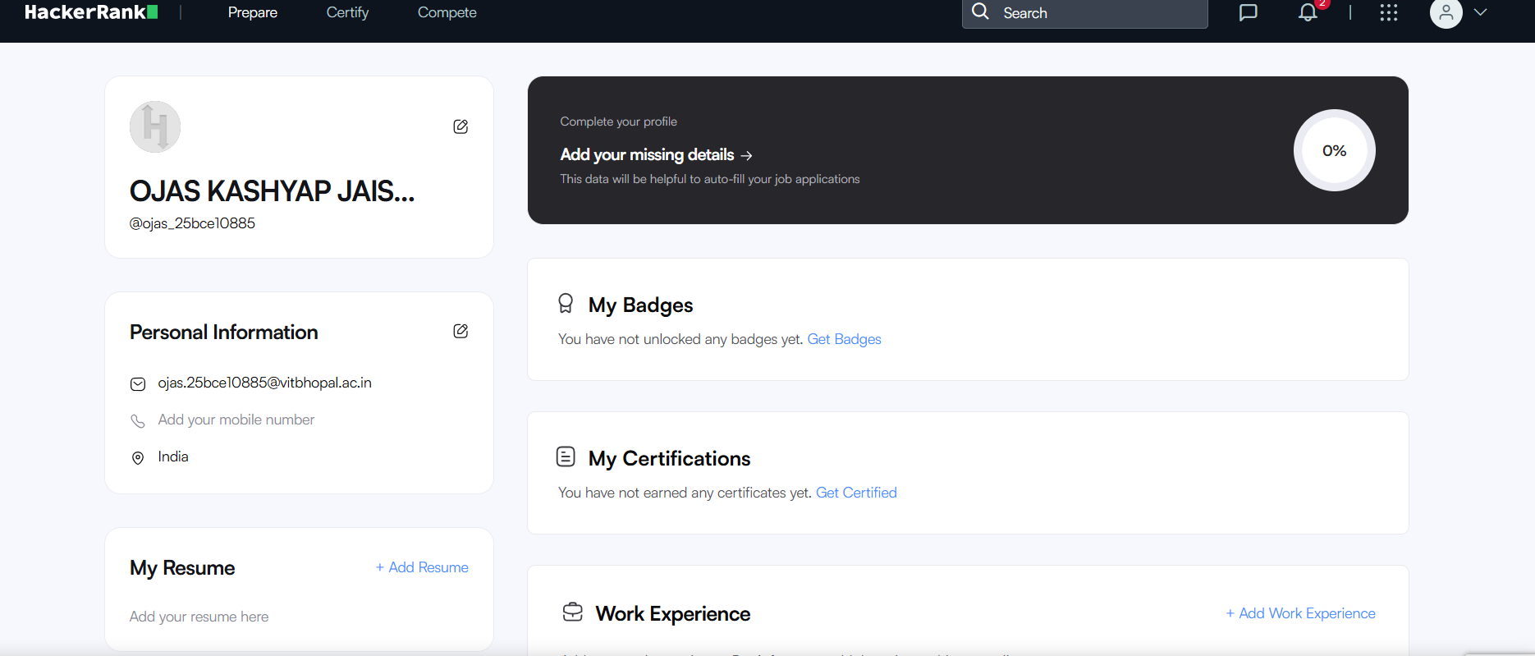
VISIT HACKERANK

